|  |  |
| --- | --- |
| No. of Pages | **5** |
| No. of Questions | 7 |

**Department of Computer Science and Engineering**

**FINAL EXAMINATION SPRING 2014**

**CSE490/EEE453: LAN Switching and WAN Technologies**

**Total Marks:75 Time Allowed: 3 Hours**

* Answer any **FIVE (5)** questions out of the given **SEVEN(7)** questions.
* Figure in bracket [] next to each question indicates marks for that question.

###### Question No. 1

**Figure No. 1**

SW1(config)#interface fa0/11

SW1(config-if)# switchport mode access

SW1(config-if)# switchport access vlan 10

1. Refer to the above commands shown in figure no.1. What will happen if a “no” is put in front of the last command, what effect will it have on the port fa0/11? [3 marks]
2. A switch has static VLANs configured. Three workstations are connected to the same Switch port by using a hub. What is the effect of this? [3 marks]

http://assessment.netacad.net/assessment/images/179579_Option22.jpeg

**Figure No. 2**

1. How do the commands shown above in figure no.2 help during configuring a switch? [3 marks]
2. How can we check whether the domains of all switches of a network are the same VTP? What happens if they are not? [3 marks]
3. State the main difference between a voice vlan and a data vlan? [3 marks]

Question No. 2

1. Which configuration changes will increment the configuration revision number on the VTP server? [3 marks]
2. A sever switch is reset. How does it obtain VLAN information? [2 marks]
3. Differentiate between Summary advertisement and Request advertisement. [3 marks]
4. State two common problems associated with Intervlan Routing? [3 marks]

R(config)#interface f0/1.2

R(config-subif)#encapsulation dot1q 20

R(config-subif)#ip add 172.18.0.1 255.255.255.224

R(config-subif)#interface f0/1.3

R(config-subif)#encapsulation dot1q 30

R(config-subif)#ip add 172.18.0.161 255.255.255.224

R(config-subif)#interface f0/1.4

R(config-subif)#encapsulation dot1q 40

R(config-subif)#ip add 172.18.0.193 255.255.255.224

R(config-subif)# interface f0/1

R(config-if)#no shutdown

**Figure No. 3**

1. Referring to the commands shown in figure no. 3, suppose that the router receives a frame on physical interface f0/1.The source IP is 172.18.0.31 and the destination IP address is 172.18.0.200 What will the router do? [4 marks]

## Question No. 3

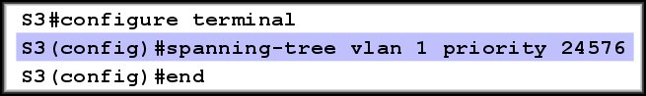

**Figure No. 4**

1. Explain why a network administrator is giving the above commands to Switch S3 shown in figure no. 4? [3 marks]

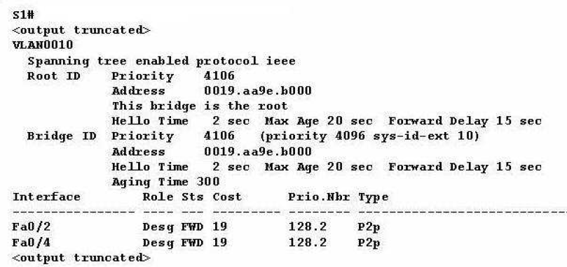

**Figure No. 5**

1. Refer to the figure no. 5 above, what is the port priority of the ports? When do we have to use the port priority numbers? [4 marks]
2. What is the difference between forwarding state and learning state? And what are they called in RSTP? [4 marks]
3. What is the difference between Edge and Non Edge ports? How do they make RSTP faster? [4 marks]

## Question No. 4

1. If there are no matches to the parameters defined in an ACL list, what happens? Why? [3 marks]

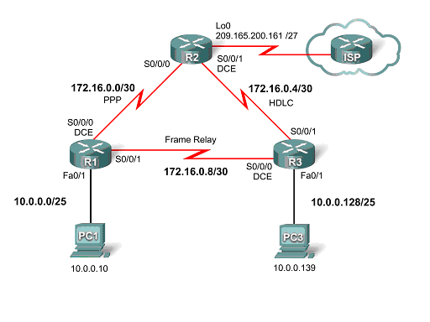

**Figure No. 6**

1. Refer to the figure no. 6 above, configure a named ACL called **ACCESS** so that all hosts from the 10.0.0.0/25 and 10.0.0.128/25 cannot ping any networks in the Internet except for PC1, but all other types of traffic from both networks is allowed. DON’T forget to place the ACL. [5 marks]
2. Referring to the same figure no.6 above, the network administrator wishes to block all telnet access into the router R2 except PC1 with the IP address 10.0.0.10 will be allowed to telnet into the router R2. Write the ACL and place it properly. [4 marks]
3. What do we have to do to edit Numbered ACLs? [3 marks]

## Question No. 5

<output omitted>

ip dhcp excluded-address 200.20.21.11 200.20.21.15

ip dhcp excluded-address 200.20.21.254

ip dhcp pool SALESNetwork

network 200.20.20.0 255.255.255.0

default-router 200.20.21.254

dns-server 200.20.21.10

!

interface FastEthernet 0/0

ip address 200.20.21.250 255.255.255.0

duplex auto

speed auto

!

<output omitted>x

**Figure No. 7**

1. Refer to router configuration output shown in figure no. 7. When hosts are requesting address, sometimes duplicate address error are prompted. What is wrong with the configuration? [3 marks]
2. What commands are used to statically map the following private address to the public address using NAT?
   * + 1. /24 to 141.63.7.20 / 28 [3 marks]
3. When do we use “ip helper address” in a router? [2 marks]
4. “show ip nat translations” will display what information? [2 marks]

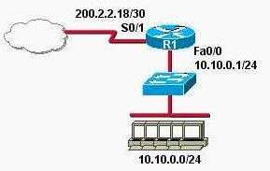

**Figure No. 8**

1. Refer to the figure no. 8 above. Write the commands, that are necessary to dynamically assign the inside address space, 10.10.0.0/24, to a NAT pool of 200.2.2.96/29. [5 marks]

Question No. 6

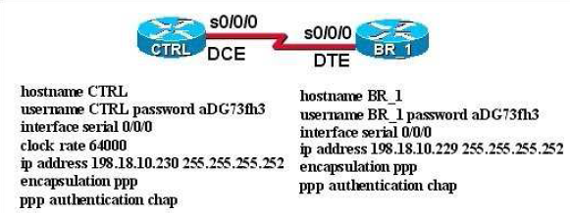

**Figure No. 9**

1. Refer to the figure no. 9 above. The link between the CTRL and BR_1 routers is configured as shown in the exhibit. Why are the routers unable to establish a PPP session? [3 marks]
2. For the same diagram above what will change if we wish to have PAP instead of CHAP? [4 marks]
3. Alongside authentication LCP also negotiates for other parameters for a PPP link? What are they? [3 marks]
4. What command can be used to verify that NCP is doing its job? [3 marks]
5. Compare HDLC and PPP. [2 marks]

## Question No. 7

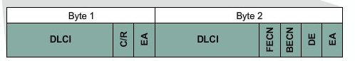

**Figure No. 10**

1. What is the purpose of the “FECN” and “DE” bit in Frame Relay shown above in figure no. 10? When is it used? [4 marks]

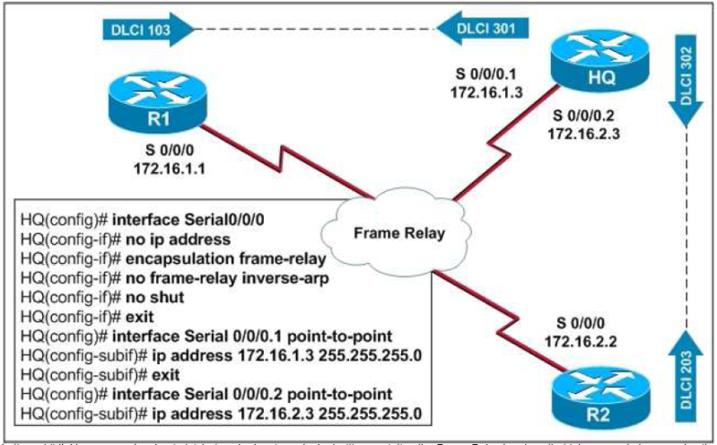

**Figure No. 11**

1. For figure no.11, what is the effect of the fourth command? How will HQ map the DLCI numbers to IP addresses? [4 marks]

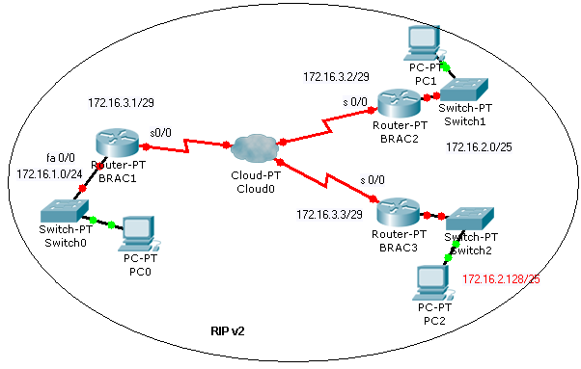

**Figure No. 12**

1. For figure no.12, serial 0/0 on BRAC1 is configured as a multipoint interface to communicate with BRAC2 and BRAC3 in this hub-and-spoke Frame Relay topology. While testing this configuration, a technician notes that pings are successful from hosts on the 172.16.1.0/24 network to hosts on both the 172.16.2.0/25 and 172.16.2.128/25 networks. However, pings between hosts on the 172.16.2.0/25 and 172.16.2.128/25 networks are not successful. Explain this connectivity problem and how to solve it? [4 marks]
2. “LMI between two routers has to match”, true or false, explain briefly. [3 marks]

##### THE END